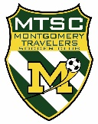
MONTGOMERY TRAVELERS SOCCER CLUB
How to Get a NJYS Coach Pass
UPDATED: 08/23/23 rjs
BACKGROUND: To obtain a NJYS Coach Pass, coaches must have a coaching license, concussion certificate, and SafeSport certificate, and undergo a criminal background check. The Coach Pass must be renewed each seasonal year (9/1 to 8/31). Renewal requires a SafeSport refresher course each year and re-authorization of the background check every 2 years. The coaching license and concussion certificate are good for life.
HOW TO OBTAIN YOUR CERTIFICATES:
COACHING CERTIFICATE: To schedule your State Coaching Certificate (formerly F License) course, click here. This is a 3 hour online plus 3 hour in-person course. Cost is $ 50; the Club will reimburse you. Be sure to download your certificates when complete; this is valid for life. Send a receipt to treasurer@montgomerysoccer.org to be reimbursed.
CONCUSSION CERTIFICATE: You can take the CDC HEADS UP Online Training, or the National Federation of State High School Associations Concussion in Sports Online Training. Both are free. Be sure to download your certificates when complete; these are valid for life.
SAFESPORT CERTIFICATE: To get your initial (90 minutes) or annual refresher (30 minutes) SafeSport cert, click here. Be sure to download your certificate when complete and save for your records.
BACKGROUND CHECK: This is done online by NJYS. You authorize this at the same time you upload your certs (see below).
HOW TO UPLOAD CERTS AND AUTHORIZE BACKGROUND CHECK:
You do this using your MTSC account (the same one you use to register your child(ren). Do this on a computer or tablet, NOT on a phone. If you are a professional coach, use your existing MTSC account or set one up if you don’t have one.
- Log into your MTSC account.
- On the left side, click
- At top right, click
- You’ll see a list of roles. Click on your role. (NOTE: you may need to scroll left or right to see it). Be sure to click “Head Coach” if you are a professional coach, and “Assistant Coach” if you are a volunteer parent coach.
- Click on your name.
- IMPORTANT: Scroll to the bottom of the page and click
- Enter (or correct) all of the information requested
- Upload a photo if one is not there already. This must be head-and-shoulders, no glasses or head covering, like a passport photo.
- Under “ACKNOWLEDGEMENT…” Click on the button, read and e-sign.
- Under “Coach Compliance…” Click on button, read, and e-sign.
- Click to upload your SafeSport Cert. NOTE: if you see “Document Verified” it was already transmitted to NJYS automatically and you can skip this.
- Click and to upload these. If uploaded in a prior year, your will see “Document Verified” and you can skip.
- IMPORTANT: Scroll to the bottom of the page and click
- Now you will see a status summary (note that “Risk Status” means Background Check):
- 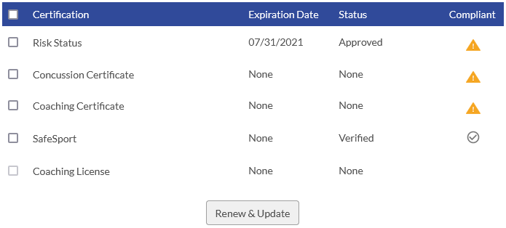
- Don’t worry about the details here if you followed the steps above.
  - Risk Status will change from Approved to Verified when NJYS completes the background check.
  - Concussion and Coaching certs will change from Uploaded to Verified when NJYS staff looks at your certs and verifies they are valid.
  - For SafeSport, if you uploaded the cert, the same applies. If it was automatically transmitted, it will say “Verified” here.
- You’re all done… THANKS! You can assume all is OK unless I contact you. The pass is usually issued within a week; I’ll email this to you, your Team Manager, and team Game Day Coordinator.

